CAÑON CITY SCHOOLS
DIRECT DEPOSIT AUTHORIZATION

EMPLOYEE’S AUTHORIZTION- Please fill out and return to the Payroll Department
I authorize you and the financial institution(s) listed below to deposit my pay automatically to my bank account(s) each payday. This authorization will remain in effect until I have cancelled it in writing.

1. |  |  |  |  |  | Checking
 |  | Financial Institution |  | Account Number
 |  |  |  |  |  | Savings
 |  | Routing Number |  | Direct Deposit Sure Pay (Main Account)

2. |  |  |  |  |  | Checking
 |  | Financial Institution |  | Account Number
 |  |  |  |  |  | Savings
 |  | Routing Number |  | Amount or % to be Direct Deposit

3. |  |  |  |  |  | Checking
 |  | Financial Institution |  | Account Number
 |  |  |  |  |  | Savings
 |  | Routing Number |  | Amount or % to be Direct Deposit

4. |  |  |  |  |  | Checking
 |  | Financial Institution |  | Account Number
 |  |  |  |  |  | Savings
 |  | Routing Number |  | Amount or % to be Direct Deposit

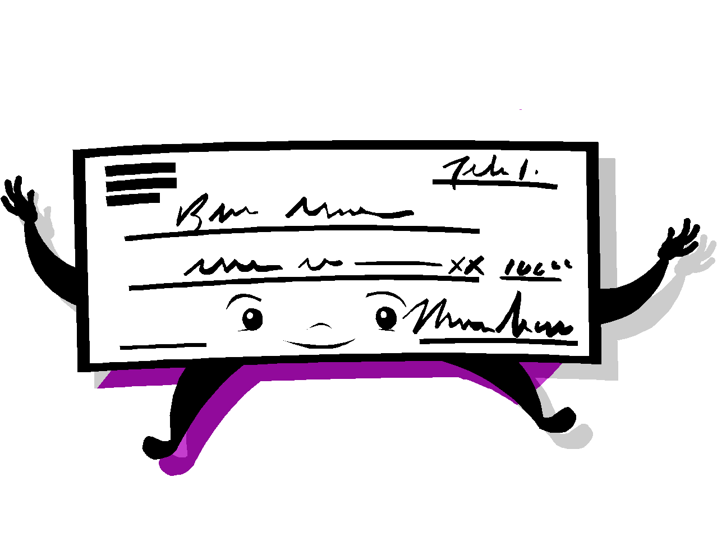
Employee Signature
Name (Please Print)
Date

